**Peregian Springs ARCare**

**JobNumber**

**Revision A**

**Car Park Maintenance Report**

**Service Performed: 1/06/2018**

*Document Version: Tuesday, 9 October 2018*

# Site Information

|  |  |
| --- | --- |
| **Site Address** | 33 Ridgeview Drive, Peregian Springs |
| **Site Name** | Peregian Springs ARCare |
| **Service Date** | 1/06/2018 |
| **Service Company** | Integrated Control and Automation |
| **Service Personnel** | Michael Sargent |

# Service Contact

|  |  |
| --- | --- |
| **Company** | Integrated Control and Automation |
| **ABN** | 80 528 804 569 |
| **Postal Address** | P.O. Box 1645 Carindale, QLD 4152 |
| **Telephone** | 07 3890 8112 |
| **Email** | office@integratedengineering.com.au |

# Aim

The aim of the work performed is provide safe and energy efficient (if used to control ventilation) CO control of the car park via the maintenance of the existing CO sensors.

# Objective

The aim will be achieved by inspecting and calibrating, where necessary, each individual CO sensor in the car park. Sensors which are reading incorrectly will be calibrated and any faulty sensors will be noted and building personnel notified.

# Procedure

If this was the first time the service had been performed for this site by Integrated, an initial survey as performed:

1. Familiarise ourselves with the floor plan and identify locations of the CO sensors and ventilation fan.
2. Record the sensor and fan identification and locations on a site plan.

Each individual sensor was then subjected to the following service procedure:

1. Visually inspect the external and internal sensor for any obvious signs of failure or damage.
2. Purge the sensor with an inert gas.
   1. While subjecting the sensor to the inert gas, the sensor output across the test terminals was recorded.
   2. If the output did not read 4mA, then the zero potentiometer was adjusted until 4mA was reached.
3. Subject the sensor to the test gas of known concentration. (50 ppm in this case)
   1. While subjecting the sensor to the test gas, the sensor output across the test terminals was recorded.
   2. If the output did not read the expected mA output, then the span potentiometer was adjusted until the correct mA output was reached.
4. Label the gas sensor housing stating calibration date, service person, and the next service due date.

The current on each ventilation fan was also measured and recorded to ensure even load on the phases, and to monitor performance of the fan motors.

# Test Equipment Details

## Inert Gas

|  |  |
| --- | --- |
| **Gas** | Air zero grade |
| **Concentration** | THC < 1ppm |
| **Cylinder Number** | 858773 Cylinder 31 |
| **Expected Zero Readings** | 4mA across the test terminals |

## Test Gas

|  |  |
| --- | --- |
| **Gas** | CO Gas in air or nitrogen |
| **Concentration** | 50ppm |
| **Cylinder Number** | Lot 861746 Cylinder 22 |
| **Expected Zero Readings** | 6.66mA across the test terminals |

## Multimeter

|  |  |
| --- | --- |
| **Manufacturer** | AMPROBE |

## Gas Sensor

|  |  |
| --- | --- |
| **Gas Sensor Details** | |
| **Manufacturer** | MSR |
| **Model** | Gard Transmitter |
| **Output** | 2-10VDC |
| **Nominal Range** | 0-150ppm |

# Calibration Equation

The relationship between proper current output and gas centration is given by Equation 1, and seen in Figure 1:

Equation 1: I = f(C)

$$Current \left[mA\right]= \left(\frac{16*Concentration_{ppm}}{SensorRange_{ppm}}\right)+4→i.e\left(\frac{16*100}{150}\right)+4=14.66 mA$$

The current is to be measured across at resistor so the expected voltage range is 2-10 volts DC.

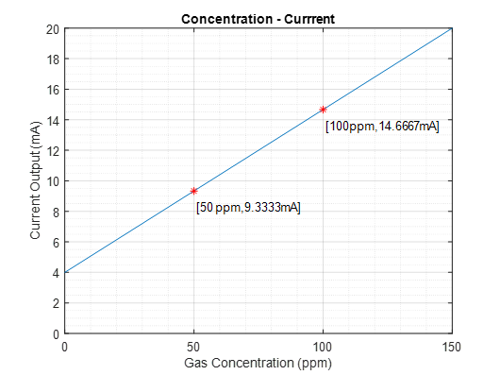

Figure 1

# Sensor Location

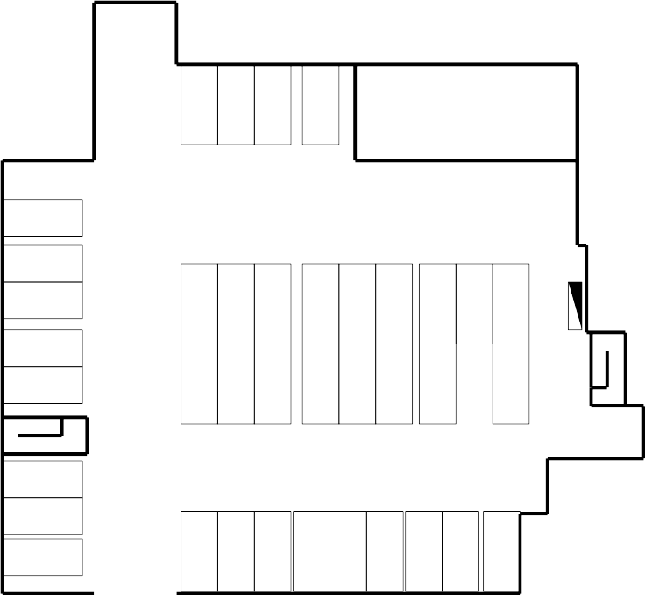

# Site Equipment Details

## Gas Sensor Calibration

|  |  |  |  |  |  |  |
| --- | --- | --- | --- | --- | --- | --- |
| **Gas Sensor Calibration** | | | | | | |
| **Last Service** | **Location** | **Sensor ID** | **Zero Reading** | | **Span Reading** | |
| **Original** | **Calibrated** | **Original** | **Calibrated** |
| June 2014 | CarPark | CO-1 | 2.002 | N/A | 7.61 | 7.34 (VDC) |
| June 2014 | CarPark | CO-2 | 1.984 | 2.001 | 7.68 | 7.33 |
| June 2014 | CarPark | NO 2 | N/A | N/A | N/A | N/A |

## Ventilation Fan Calibration

|  |  |
| --- | --- |
| **Ventilation Fan Details** | |
| **Fan Type** | Supply / Exhaust |
| **Fan Identification** | EXHCPEF1 |
| **Location** | Straight ahead from entrance, behind bus parking. |
| **Manufacturer** | FANTECH |
| **Model** | AP0806GA6B022 |
| **Control Method** | VSD |
| **Red Phase** | 2.5 A (Set to manual, VSD read @ 45Hz) |
| **White Phase** | 2.4 A (Set to manual, VSD read @ 45Hz) |
| **Blue Phase** | 2.7 A (Set to manual, VSD read @ 45Hz) |
| **Ventilation Fan VSD Details** | |
| **Manufacturer** | SANTERNO |
| **Model** | SINUS M |
| **Frequency** | 45 Hz |
| **Mode** | MANUAL |
| **Associated MSSB** | MSSB-1 |

# Findings

# All the CO sensors gave stable readings however calibrations were required for one of the sensors.

# The fan currents measured were equal and satisfactory. The currents were read by forcing the fan in manual mode. Manual mode controlled the fans to between 45Hz via to the VSD. It is preferable to measure the currents when the fan is at maximum load.

# Recommendations

Following from the car park service, the following recommendations are as follows:

* Continue to retest sensors every 6 months. To ensure safe and efficient ventilation a calibration is due on the 19th January 2019.